Hi.
Here is an overview of my trading background, strategy, and funding requirements.

1. About Me
My name is Giannis (John) Christopoulos, and I am from Kalamata, Greece. I have been exclusively focused on developing and automating Forex trading strategies for the past 11 years. Through in-depth market analysis, I identified a recurring bar pattern that consistently appears after moderate to significant economic announcements, providing a reliable indication of short-term trend direction.

2. About the Pattern
The strategy is based on the Railway Track Pattern, Price Action, and the Fibonacci sequence, identifying high-probability trade setups driven by post-news volatility. Since this pattern is not dependent on tight spreads or ultra-fast execution, it performs equally well in both simulated and live conditions.
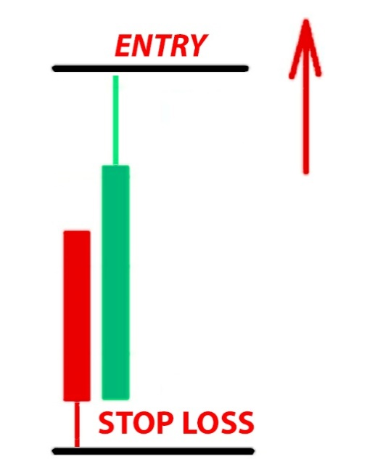

3. My Simulated Strategy (Backtested Results)
Before going live in 2024, my strategy was backtested over 15 years (2008 – 2023), achieving:
✅ Compound Annual Growth Rate (CAGR): 90%
✅ Win/Loss Ratio: 1.50
✅ Profitable Trades: 59.93%
The backtest was conducted using compounding (profit reinvestment) to maximize capital growth.

4. My Live Trading Strategy
In early 2024, the brokerage firm InstaForex approached me through my website, offering to fund my strategy with $10,000. Over the past year, my strategy has successfully doubled the initial capital in a live trading environment. You can verify the real-time performance here:
🔗 https://www.myfxbook.com/members/giannis/funded-instatrader/10605583

5. Simulated vs. Live Performance
At the end of 2024, I conducted a new simulation to compare the live results with the backtest:
✔ Same number of trades
✔ Same Risk/Reward ratio
✔ Same profitability
✔ Same profit in both backtest and live trading
✔ Higher Profit Factor in live trading (due to calculation differences between backtest and Myfxbook metrics)
Even the balance and equity curves match closely, confirming the robustness of the strategy across different environments.
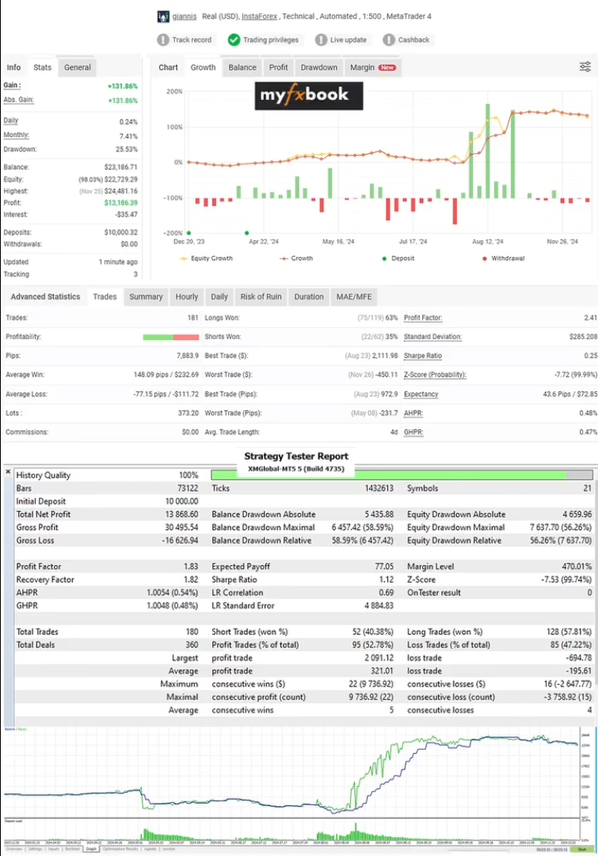

Strategy Tester Report on 500:1 LEVERAGE
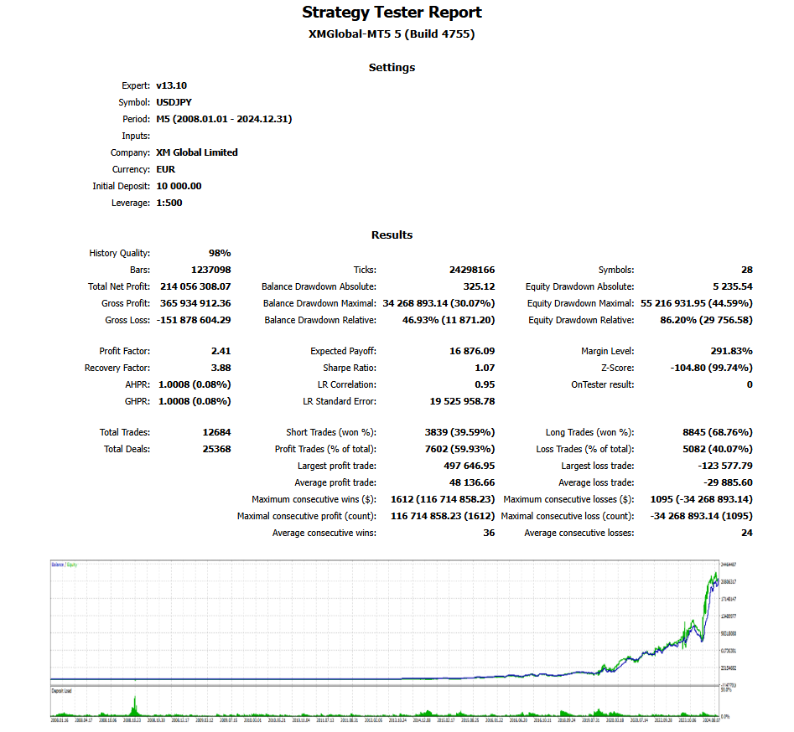

Strategy Tester on 500:1 YEARLY LEVERAGE DRAWDOWNS
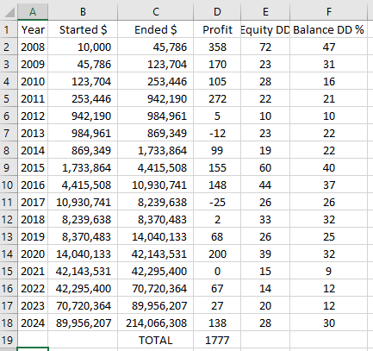

Quant analyzer Report on 500:1 LEVERAGE MONTHLY
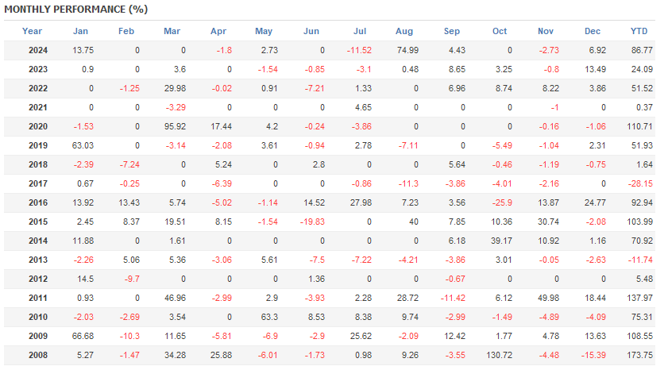
Myfxbook Report on 500:1 LEVERAGE MONTHLY
